Seeking Resident Friends for Auckland, Aotearoa New Zealand

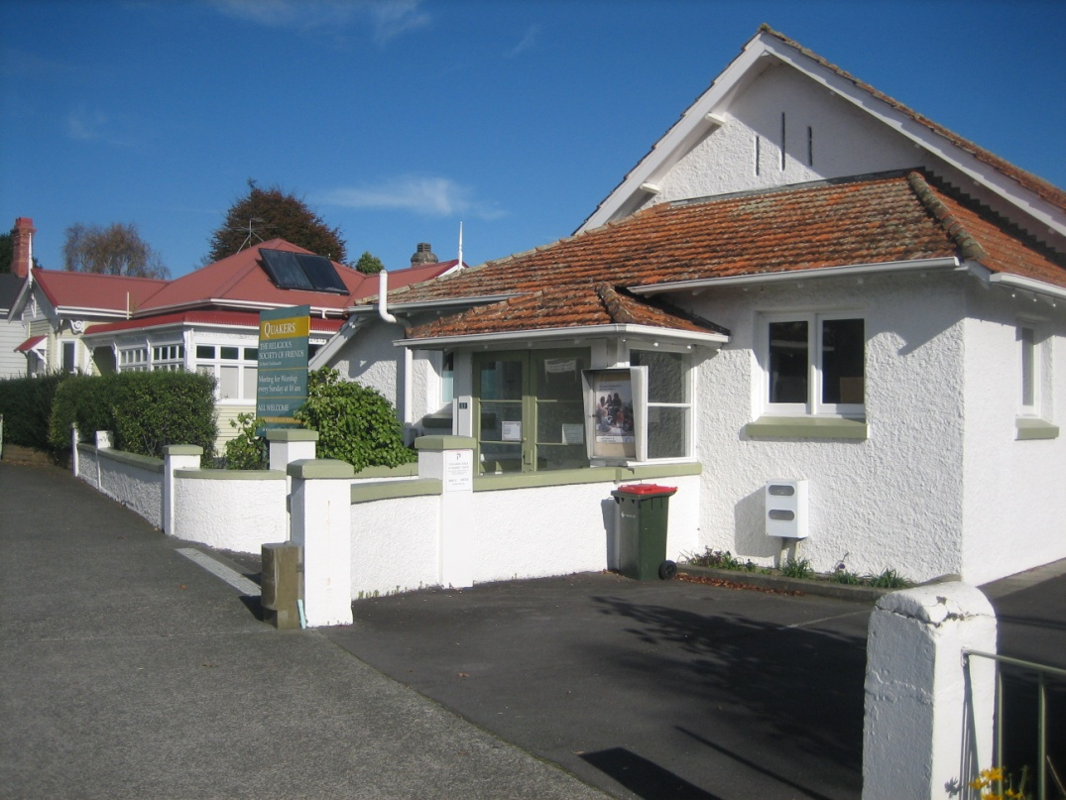

The Meeting House, Mt Eden, Auckland with Friends Centre to left

You are invited to spend a year as Resident Friends in Auckland where you will be part of a lively Quaker community.

We’re looking for a Quaker couple to live in the Friends Centre from the beginning of April 2026 for a period of a year or more and be involved in the spiritual and social life of Northern Monthly Meeting. Duties include running the 4-bed accommodation facility for travelling Friends.

For information and a job description please contact John Flack [premises@nt.quakers.nz](mailto:premises@nt.quakers.nz)